Community Partnerships for Healthy Mothers and Children – Existing Resources & Directions for the Future
By Anna Bondy
Abstract
The goal of this project is to improve poor nutrition and lack of access to healthcare among women and children in the Baltimore community over a 3 year period through the formation of a community coalition. This report identifies the existing resources in the community as part of a larger needs assessment, and suggests future interventions. Existing resources that are examined include healthy food options in corner stores, procurement teams to increase purchasing opportunities, farmer’s markets, and acceptance of EBT payments from WIC/SNAP, awareness of healthy food outlets and preparation among residents, nutrition information on product displays, and training of store managers in purchasing, placement, and food preparation.¹
The needs assessment also identifies regions and populations in Baltimore that are disproportionately affected by these issues through GIS mapping. Combined with statistics and other analysis, this data will be used to decide the intervention priorities of the community coalition. Ultimately, the goal is to empower communities to create sustainable solutions for women and children in need of healthy food and adequate healthcare.¹
Goals Analysis
According to my goals analysis, the three core competencies that I hoped to fulfill were analytical/ assessment skills, policy development/ program planning skills, and cultural competency skills. My capstone project has allowed me to strengthen my skills in these core competencies in several ways. The needs assessment has allowed me to hone my assessment skills through the analysis of maps, statistics and graphs related to food access in Baltimore City. I was also able to use what I learned about program planning in developing my capstone essay. Finally, I built on my cultural competency skills to better understand the needs of the Baltimore community by learning about the geography and history of Baltimore.

I. Project Context
Two main risk factors for chronic disease are poor nutrition and lack of access to chronic disease prevention, risk reduction, and management opportunities.² As part of a three year project “to create and implement community-driven plans to reduce chronic disease through policy, systems, and environmental (PSE) strategies, ” the CDC has funded a 15-month grant targeting poor nutrition and lack of access to healthcare in Baltimore city. ² This grant was offered through three main organizations – the National WIC Association (NWA), the American Planning Association, and the American Heart Association ². The following is a program plan for the first phase of this project. This grant targets these risk factors in the target population of mothers and their children in Baltimore City. ²
Baltimore is known as an industrial city and was a large producer of steel, cans and garments at one time. It is also known for the rowhouses, and alleys that dominate the landscape. Although White people and Black people once lived in the same neighborhoods, formal and informal racial segregation in the 20th century is largely responsible for the current racial make-up of the city (see appendix A). After World War II, tens of thousands of wartime jobs disappeared, in addition to the large number of firms that moved from the city to the county. White flight to the suburbs particularly affected West Baltimore, where some of the highest rates of vacant housing were reported. These west Baltimore neighborhoods became predominantly Black. New neighborhoods were established just outside the city limits at the time and were governed by strict rules in their property deeds prohibiting Blacks from moving in. In the 1950s and 1960s, urban renewal projects demolished downtown slums without creating new affordable housing, forcing former slum residents to move east and west of downtown, and increasing the divide between the rich and poor areas of the city. These events, combined with the use of redlining and neighborhood covenants, resulted in neighborhoods that are largely racially segregated today.³
In 2014, Baltimore city had an estimated population of 622, 793 people, making it the 21st largest city in the United States.⁴ Baltimore is also ranked 11th in transportation, despite the fact that there is only one subway and one light rail line.⁵ Baltimore is largely a car city – crossed by I-95 and I-83 and bounded by the I-695 beltway. Baltimore County borders the northern boundary of the city and Anne Arundel County is in the south. The lack of large highways in Baltimore City contributes to the distinctive neighborhood atmosphere. According to census data, 31.6% of the population is white, 63.3% is African American, 2.6% is Asian, and 4.6% Hispanic.⁶ However, the city is largely divided on racial lines – with predominantly white areas reaching north from downtown and predominantly black neighborhoods in the east, west, and northeast (see Appendix A).⁷ The per capita income in 2013 was $24,750, but there are large areas of concentrated poverty (see Appendix B).^{6,7} With regard to education level, 80.2% of the population have at least a high school diploma, and 26.8% have a bachelor’s degree. ⁶
Chronic conditions, such as obesity, diabetes, hypertension and cardiovascular disease, have been shown to disproportionately affect urban, low income, and minority groups. ^{8,9} According to Healthy Baltimore 2015, 39.4% of Baltimore adults earning $15,000 or less are obese, compared to 33.8% overall and 16.5% in city residents earning $75,000 or more.¹⁰ One of the key components to prevention of chronic disease is access to healthy, affordable food. However, these same low-income groups are also less likely to have access to a grocery store, with an estimated travel time of 29.1 minutes to the nearest grocery store in some of the lowest access areas in Baltimore city – 16 times that of the highest access neighborhoods.¹⁰
Communities that lack access to healthy food have been called “food deserts”.⁹ The Baltimore City Food Policy initiative defines a food desert as:
An area where the distance to a supermarket is more than ¼ mile, the median household income is at or below 185% of the Federal Poverty Level, over 40% of households have no vehicle available, and the average Healthy Food Availability Index score for supermarkets, convenience and corner stores is low (measured using the Nutrition Environment Measurement Survey). ¹¹
Food deserts are also characterized by an abundance of unhealthy foods available in corner stores and carry out restaurants. Food deserts disproportionately impact children in Baltimore city with 1 in 5 adults and 1 in 4 children without access to healthy, affordable food.¹¹ According to the Baltimore Youth Risk Behavior Survey, 17% of high school students were obese (>95th percentile for BMI) in 2013.¹²
This is consistent with a national survey that estimated 20.5% (95% CI: 17.1 – 24.4) of adolescents, ages 12-19, were obese in 2012, and 34.5% were overweight or obese.¹³ The National Center for Health Statistics also estimated the prevalence of overweight and obesity in American children ages 2-5 at 22.8%.¹³ If one third of overweight children and one half of overweight adolescents become obese adults, this risk factor for future development of chronic disease is a serious public health concern.¹⁴
II. Existing Community Resources
The Baltimore city government is aware of the food access issues facing its citizens. The recognition that adequate numbers of grocery stores in Baltimore City is not only a planning issue, but also a public health issue led to the establishment of a food policy council in 2008, called the Baltimore Food Policy Initiative (BFPI). ¹⁵
The Johns Hopkins Center for a Livable Future published a report in 2010, titled “The Baltimore City Food Environment”.¹⁶ One notable finding of this report was that national definitions of grocery stores may not be suitable for the Baltimore food environment. Many corner stores are classified as corner stores, but in actuality sell mostly tobacco and other general merchandise, with only a few types of food available. Therefore, access to a corner store in Baltimore does not guarantee access to healthy foods. ¹⁶
Additionally, the report found that predominately African-American neighborhoods have significantly lower access to healthy food, according to the Healthy Food Availability Index (based on the availability of milk products, fresh fruits and vegetables, low-sodium foods and other food products in individual stores). These same neighborhoods have a greater proportion of behind-glass convenience stores, compared to predominately white neighborhoods.
As part of the needs assessment, an analysis of existing resources and programs in Baltimore City was performed. Recommended interventions from the CDC include promotion of healthy food options in corner stores, procurement teams or food cooperatives to increase purchasing opportunities, increasing farmer’s markets, and those that accept EBT payments and checks from SNAP and WIC, raising awareness of healthy food outlets and preparation among residents, inclusion of nutrition information on product displays, especially those targeting youth, and training of store managers in purchasing, placement, and food preparation. Therefore, these interventions were used as a starting point to explore food access interventions in Baltimore City. Not included in the interventions outlined by the grant, but an important consideration for further work, is the level of transportation available to and from healthy food.¹⁷
Healthy Food Options, Product Displays & Store Training
Common strategies to increase healthy food options include improving availability of healthy foods, such as low-fat milk and whole wheat bread, decreasing the availability of unhealthy foods, or introducing healthy foods in multiple phases. Product displays have been used in the form of signage inside the store, as well as media campaigns outside the store. Coupons, newsletters, educational handouts and cooking demonstrations have also been used as product promotions tools in healthy store interventions. Capacity building interventions for store owners have provided health education and business training, including stocking and handling methods for fresh produce.¹⁸
In 2007, Dr. Joel Gittelsohn at the Bloomberg School of Public Health was the recipient of a Robert Wood Johnson Foundation Heathy Eating Research grant ¹⁹. This grant funded the first 10-month Baltimore Healthy Stores intervention and determined the feasibility of using stocking and promotion of healthy foods to increase sales. It showed small but significant increases in healthy food sales in corner stores located near schools and community centers, and suggested that a longer trial would have more significant impacts.²⁰ The Baltimore Communities for Healthy Kids is currently ongoing and aims to change beverage, snack and cooking behaviors by determining barriers at the individual and store level, and finding cost effective solutions. ²¹
One of the goals of the BFPI is to improve the food environment around schools and recreation centers.²² In 2014, Baltimarket won a grant from the Maryland Community Resources Commission to promote sustainable changes in food access and equity in Baltimore City. ²³ In cooperation with the Youth Neighborhood Food Advocates and the BFPI, Baltimarket used this grant to start a pilot that would implement the Baltimore Healthy Stores program over a 3 year period.²³ This program aims to increase stocking of healthy foods in 18 corner store locations, provide nutrition education along with some environmental changes in 3 corners stores, and organize 75 youth to advocates to assist in these transformations. ²³ The primary focus of this project is the West Baltimore Health Enterprise Zone, and it hopes to reach 12,100 people. ²³
The neighborhood food advocates is a community organizing program in collaboration with the Baltimore city health department. The goals of the organization include creating change in the Baltimore food system through education, food delivery, increasing availability of healthy food and the creation of a community coalition. ²⁴ Neighborhood food advocates is also responsible for organizing youth involved in the Baltimore healthy stores program with the goal of generating demand for healthy foods. ²⁵
There is also a grocery store program being piloted by the Center for a Livable Future called, “Eat Right Live Well”, at the Food Depot in southwest Baltimore.²⁶ This program aimed to increase healthy food purchasing through the use of “product labeling, re-positioning of products, and price manipulation to make healthier foods more attractive.”²⁷ The store also hired a full-time dietitian who offered grocery store tours, taste tests and recipe cards.^{26,28} The Food Depot accepts both WIC and SNAP, and taste tests were held during peak SNAP days to reach more customers. ²⁶ The research team also participated in community outreach to increase awareness of healthy options in the community. ²⁶
Although aspects of healthy food availability, including supply, promotion and store training have all been targeted for intervention in Baltimore City, the sustainability of campaigns based in educational handouts, media promotions or coupons is a consideration. Future interventions with community partners, including the Korean Association of Grocers, and participating supermarkets, may attempt to incorporate sustainability for healthy food promotion into their business, as well as discuss the promotion of healthy foods towards the WIC population, including mothers and young children. This may include removing unhealthy choices from lower shelves to decrease consumption in younger children, or targeting media messages to pregnant mothers. Programs such as Eat Right Live Well may be part of this strategy but sustainability and scaling up are both going to be issues.
Procurement
Baltimore city has multiple initiatives to increase food procurement. Work has been done to increase availability of fresh produce at city markets (i.e. Lexington Market, Cross Street Market), and create incentives for more arabbers to start serving more routes in the city ²⁹. Arabbers are people who sell produce out of a truck or a horse-drawn cart, and often service areas where there are few nearby grocery stores ¹⁶.
The BFPI also aims to expand supermarket home delivery programs. The virtual supermarket program (VSP) is an attempt to provide grocery delivery to food desert neighborhoods in collaboration with the Neighborhood Food Advocates. Currently the program has 4 ordering and delivery sites – 2 in Cherry Hill, 1 in Perkins Homes, and 1 in Wayland village. VSP has the added benefit that it accepts SNAP benefits ³⁰.
Future interventions may expand home delivery programs to more sites. Consideration should be made for delivery programs through local WIC sites, or at least having computers and guides available to do the ordering at clinics.
Farmer markets & Acceptance of EBT
One of the primary goals of the BFPI is to promote and expand Farmers’ Markets. This includes increasing access to farmers markets for SNAP and WIC participants. The BFPI developed resources for farmers on how to establish new farmers’ markets, as well as how to accept federal nutrition assistance benefits (“Farmers Markets,” 2010). Of the 20 farmers markets in Baltimore City, 7 accepted SNAP benefits in 2011, up from 3 prior to 2010 (“Farmers Markets,” 2010). There was also a 45% increase in SNAP sales at farmers markets during the 2010-2011 market season (“Farmers Markets,” 2010). Currently, 12 out of 23 farmers’ markets in Baltimore City accept EBT from SNAP beneficiaries (also see Appendix C). ^{31,32}
The Maryland Farmers Market Association also offers the Maryland Market Money program in Baltimore City. Participants in the Farmers’ Market Nutrition Program (FMNP), including WIC moms and seniors, as well as the WIC Fruit and Vegetable Check Program (FVC) and SNAP can receive matching funds when they shop at local farmers’ markets. In Baltimore City, 18 out of 23 farmers markets participate in the FMNP and FVC and 8 of those farmers markets participate in the Maryland Market Money program. ³³
Although much progress has been made to expand acceptance of WIC and SNAP, we need to continue to work towards improvement. One common problem among WIC beneficiaries is how to use the exact amount allotted to them. Creating deals with farmers so participants could use their whole fruit and vegetable check on specified groupings of food could get them closer to this goal.
Acceptance of EBT payments from WIC/SNAP in Stores
There were 955 SNAP-authorized retailers in Baltimore city in 2012, which is 153.79 retailers per 100,000 people.⁷ This is considered an adequate number of retailers overall; however when broken down by census tract, the acceptance of EBT varies. There were 237 WIC-authorized retailers in Baltimore City in 2012, which is 38.26 stores per 100,000 people.⁷ Compared to the number of stores accepting SNAP, there are significantly fewer stores accepting WIC. The main concern is that, although city-wide acceptance rates are good, the stores that accept WIC and SNAP are concentrated in specific geographic locations, leaving some areas with many stores and some with very few.
Awareness of healthy food outlets and preparation among residents
In the past, programs have targeted local community centers, and newspapers with flyers and advertisements to increase awareness of healthy food outlets. Cooking demonstrations and taste tests are common ways to encourage residents to consume healthy food alternatives by increasing self-efficacy. ¹⁸
Baltimore Healthy Eating Leading Partnerships for Seniors (HELPS) provides one-stop service centers in three locations in Baltimore City. It is supported by a coalition of community organizations and the Delmarva Foundation for Medical Care. These centers provide nutrition education, skills workshops for healthy eating on a budget, transportation to grocery stores, and information on where to find healthy foods in their local neighborhoods. The aim of the program is to support prevention and management of chronic disease. Therefore, the program also offers counseling sessions with medical professionals. ^{34,35}
Baltimore HELPS is a model program for taking a holistic approach to promoting good nutrition, however its services are only intended for older adults. Therefore, our target population of women and young children do not benefit from this service. However, community partners, such as Kaiser Permanente or Maryland Hospitals for a Healthy environment may want to use this as a model for similar programming targeting families.
Policy
The BFPI is also working to change policies to increase access to healthy foods. At the city level, zoning laws have allowed for hoop houses, community gardens and farm stands in community-managed open space without a permit since 2012. At the state level, the BFPI is advocating to eliminate the requirement for farmers’ markets to be a year old before accepting EBT or WIC checks. They were successful in changing the state’s farmers’ market policy to allow new farmers’ markets in designated food deserts to begin accepting WIC and SNAP benefits right away.³⁶ BFPI is also advocating for proposed state-enabling legislation for a personal property tax credit to supermarkets/grocery stores as a part of the Baltimore city’s food desert retail strategy. The tax credit would be given to stores meeting certain healthy food criteria that locate in or near a food desert, or for stores that renovate in areas that would be food deserts were it not for that store being there.

III. Needs Assessment
Prior to the needs assessment, the first two steps of the process had already been completed including the formation of a community leadership team, and convening a community coalition of at least 10 stakeholders. The needs assessment is due to be completed in May 2015, and will include food and health indicators from the community health needs assessment for Baltimore City, including demographics, food deserts, availability of fast food, grocery stores, maps of indicators by census tract, data from the Obstetrician-Gynecologist Distribution Atlas to assess shortages of OB-GYNs in Baltimore City indicators from the Maryland WIC agency about the WIC population, a survey of WIC families and others (n ≥ 20), and a list of partners in the community and their contact information.
Information on demographics will be used to assess who the target population(s) should be in terms of geographic location, or groups by age or race. This will help with audience segmentation for any communication programs that are created, and to produce effective messages. Information on food deserts, combined with grocery store and fast food locations will highlight key problem areas for food access issues. Information from the Maryland WIC agency will be informative with regards to whether the current WIC clinics meet the needs of the individuals they serve. Having information on locations of WIC-approved stores will also be important for assessing food access for WIC clients in non-desert areas.
IV. Action Plan
Once the needs assessment has been completed, there will be 9 months to complete phase 2 – the community action plan implementation. The action plan is intended to identify gaps, build on existing efforts, maximizing resources through coordination, and clarify the roles and responsibilities of partner organizations. Grant collaborators will then be able to decide if they want to develop new interventions or build on existing interventions, and what level they want to intervene at. Program activities and objectives will be developed collectively based on need, feasibility and desirability.
Through the needs assessment, food and healthcare needs will be identified by geographic area. During the following nine months the goal is to identify interest areas for community partners and build capacity in those organizations to further our overall objectives. By empowering existing organizations, the intention is to create sustainable improvements in food and healthcare access for women and children.
It is my belief that Baltimore already has a strong community of professionals and community members working on food access issues. Therefore, the best approach may be to work within the existing network of organizations to work on skill-building, advocacy and scaling up. I hope this project brings to light relevant issues in this population so that existing programs can more effectively cater to the food and healthcare needs of women and children long-term.

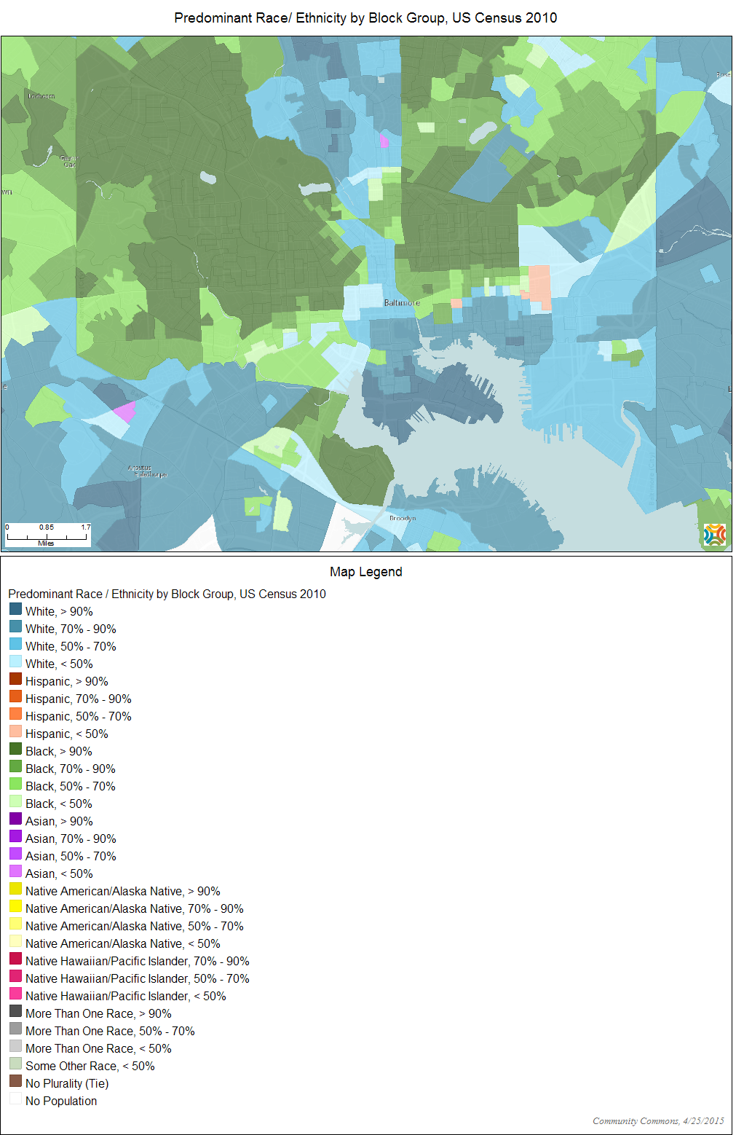
Appendix A⁷
Appendix B⁷
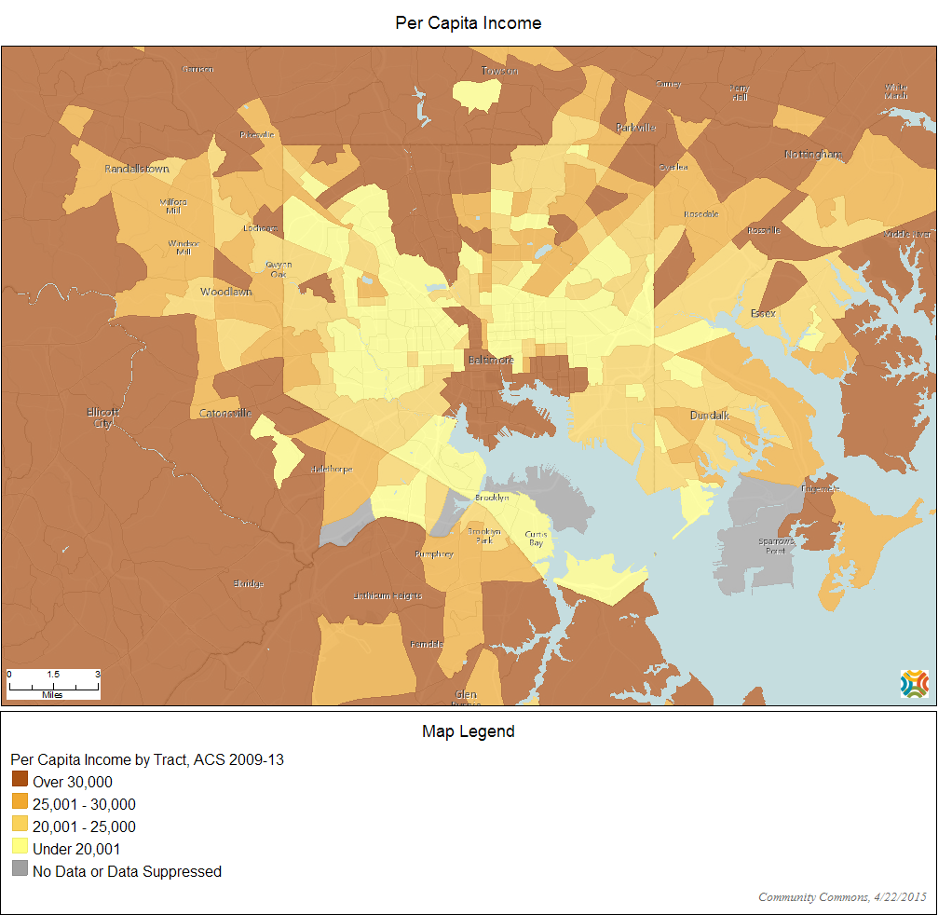
Appendix C
 | Name | FMNP & FVC^{32,37} | SNAP^{32,37} | Market Money³³
1 | 32nd Street (Waverly) | X | X | X
2 | Baltimore City (JFX) | X | X (select vendors) | X
3 | BMI | X
4 | Druid Hill | X | X | X
5 | Fells Point | X
6 | Canton | X | X
7 | Govanstowne | X | X | X
8 | Highlandtown | X | X
9 | Howard Park | X
10 | Johns Hopkins | X | X | X
11 | Park Heights | X | X | X
12 | Pratt Street | X
13 | Remington | X
14 | State Center | X | X | X
15 | Tuesday Market | X | X
16 | University | X | X | X
17 | Village of Cross Keys | X
18 | Go Life/Cylburn | X | X
19 | Charles Street |  | **
20 | Mt Washington Whole Foods
21 | Harbor Hospital Community
22 | Fresh Friday
23 | West MARC | X | **
Total |  | 19/23 (82%) | 12/23 (52%) | 8/23 (35%)

**SNAP Authorized as of 3/2014

Bibliography
1. National WIC Association. Community Health Needs Assessment Webinar. 2015:1-64.
2. Esposito M, Harris Q, Eppes E. Welcome to the Community Partnerships for Healthy Mothers & Children Project. 2015.
3. Pietila A. Not in My Neighborhood: How Bigotry Shaped a Great American City. Chicago, IL: Ivan R. Dee; 2010.
4. US Census Bureau. US Census Bureau 2010 Census Interactive Population Map. http://www.census.gov/2010census/popmap/. Accessed April 16, 2015.
5. McKenzie BS. Public Transportation Usage Among U.S. Workers: 2008 and 2009.; 2010. https://www.census.gov/prod/2010pubs/acsbr09-5.pdf.
6. Baltimore city QuickFacts. US Census Bur. 2015. http://quickfacts.census.gov/qfd/states/24/24510.html. Accessed April 16, 2015.
7. Community Commons. http://www.communitycommons.org. Accessed April 25, 2015.
8. Lucan SC, Karpyn A, Sherman S. Storing empty calories and chronic disease risk: Snack-food products, nutritive content, and manufacturers in Philadelphia corner stores. J Urban Heal. 2010;87(3):394-409. doi:10.1007/s11524-010-9453-5.
9. Zachary D, Palmer A, Beckham S, Surkan P. A Framework for Understanding Grocery Purchasing in a Low-Income Urban Environment. Qual Health Res. 2013;23:665-678. doi:10.1177/1049732313479451.
10. Childs F, Duval-Harvey J, Farrow O. Healthy Baltimore 2015. Baltimore, MD; 2011.
11. Food Deserts. Balt City Food Policy Initiat. 2010. http://archive.baltimorecity.gov/Government/AgenciesDepartments/Planning/BaltimoreFoodPolicyInitiative/FoodDeserts.aspx. Accessed March 27, 2015.
12. CDC. The Obesity Epidemic and Baltimore Students.; 2010. http://www.cdc.gov/HealthyYouth/yrbs/pdf/obesity/az_obesity_combo.pdf.
13. Ogden CL, Carroll MD, Kit BK, Flegal KM. Prevalence of childhood and adult obesity in the United States, 2011-2012. J Am Med Assoc. 2014;311:806-814. doi:10.1001/jama.2014.732.
14. Wang Y, Lobstein T. Worldwide trends in childhood overweight and obesity. Int J Pediatr Obes. 2006;1(September 2005):11-25. doi:10.1080/17477160600586747.
15. Santo R, Yong R, Palmer A. Collaboration meets opportunity : The Baltimore Food Policy Initiative. J Agric Food Syst Community Dev. 2014;4(3):193-208.
16. Haering SA, Franco M. The Baltimore City Food Environment. Baltimore, MD; 2010.
17. Shak L, Mikkelsen L, Chehimi S. Recipes for Change: Healthy Food in Every Community. Oakland, CA; 2010.
18. Gittelsohn J, Rowan M, Gadhoke P. Interventions in Small Food Stores to Change the Food Environment, Improve Diet, and Reduce Risk of Chronic Disease. Prev Chronic Dis. 2012;9(September 2010):1-15. doi:10.5888/pcd9.110015.
19. Changing Food Offerings in Baltimore’s Small Stores: The Baltimore Healthy Eating Zones Study. 2012. http://www.rwjf.org/en/about-rwjf/newsroom/newsroom-content/2012/11/changing-food-offerings-in-baltimore-s-small-stores--the-baltimo.html. Accessed March 27, 2015.
20. Song H-J, Gittelsohn J, Kim M, Suratkar S, Sharma S, Anliker J. A corner store intervention in a low-income urban community is associated with increased availability and sales of some healthy foods. Public Health Nutr. 2009;12(11):2060-2067. doi:10.1017/S1368980009005242.
21. Global Obesity Prevention Center at Johns Hopkins. B’More Healthy Communities for Kids. Baltimore, MD
22. Baltimore City Food Policy Task Force Final Report and Recommendations. Baltimore, MD; 2009.
23. Schwartzberg M. Baltimore City Receives $750,000 Three-Year State Grant To Launch Baltimarket Healthy Stores Initiative and Reduce Youth Obesity. 2014. http://health.baltimorecity.gov/news/press-releases/2014-02-26-baltimore-city-receives-750000-three-year-state-grant-launch. Accessed March 25, 2015.
24. Neighborhood Food Advocates - Baltimarket. 2015. http://www.baltimarket.org/neighborhood-food-advocates/. Accessed April 17, 2015.
25. Baltimarket | Baltimore City Health Department. 2014. http://health.baltimorecity.gov/programs/baltimarket. Accessed April 17, 2015.
26. CLF Implements Eat Right Live Well Campaign at Food Depot - 2012- Announcements - News & Events - Center for a Livable Future - Johns Hopkins Bloomberg School of Public Health. http://www.jhsph.edu/research/centers-and-institutes/johns-hopkins-center-for-a-livable-future/news-room/our-stories/2012/supermarket.html. Accessed April 27, 2015.
27. Mayor Rawlings-Blake, Food Depot, and Eat Right Live Well - 2013- Announcements - News & Events - Center for a Livable Future - Johns Hopkins Bloomberg School of Public Health. http://www.jhsph.edu/research/centers-and-institutes/johns-hopkins-center-for-a-livable-future/news-room/our-stories/2013/food-depot.html. Accessed April 27, 2015.
28. Hoehner S, Palmer A. Eat Right , Live Well ! A supermarket intervention to increase healthy food purchases. In: Linthicum Heights, MD; 2015:1-17.
29. Yong R, Freishtat H. Healthy Food Assessment : Baltimore City’s Public Markets Final Report. Baltimore, MD; 2011.
30. Virtual Supermarket. 2015. http://www.baltimarket.org/virtual-supermarket/. Accessed April 1, 2015.
31. Farmers’ Markets. 2010. http://archive.baltimorecity.gov/Government/AgenciesDepartments/Planning/BaltimoreFoodPolicyInitiative/FarmersMarkets.aspx. Accessed March 25, 2015.
32. Maryland Farmers’ Markets. http://visitmaryland.org/events/pages/marylandfarmersmarkets.aspx#baltimorecity. Accessed March 27, 2015.
33. Maryland Market Money Launches at 10 Farmers Markets in Baltimore. 2014. http://www.marylandfma.org/maryland-market-money-launches-at-10-farmers-markets-in-baltimore/. Accessed March 27, 2015.
34. HELPS Program - Baltimarket. 2015. http://www.baltimarket.org/helps-program/. Accessed April 17, 2015.
35. Healthy Eating Leading Partnerships for Seniors (HELPS) - Baltimarket. 2015. http://www.baltimarket.org/healthy-eating-leading-partnerships-for-seniors-helps/. Accessed April 17, 2015.
36. Baltimore City Food Policy Initiative. Planning / Baltimore Food Policy Initiative / Food Policy. 2010. http://archive.baltimorecity.gov/Government/AgenciesDepartments/Planning/BaltimoreFoodPolicyInitiative/FoodPolicy.aspx. Accessed April 17, 2015.
37. No Title. http://maps.google.com/maps/ms?msid=212886408888022222034.0004a59c795fb18f06250&msa=0&ll=39.309332,-76.632385&spn=0.241733,0.431213.

