
August 20, 2010
There are only three weeks left in the Healthy Destinations challenge. Be sure to get your extra 100 miles by filling out the Know Your Numbers card and doing your Health Risk Assessment online. Thanks to HealthTrax for their lecture on Cardiovascular Health this week. Next week will be Infection Control.
GROCERY STORE TIPS & TRICKS
Below are some grocery store tricks and tips that can be helpful when trying to buy healthy foods on a budget at the grocery store.
- Wholesome, unprocessed foods such as fruits, vegetables, milk, yogurt, and meat can all be found on the outer edges of the grocery store. Try to do most of your shopping in these areas.
- The products that are on eye-level at the grocery store are not always the healthiest or the best value, look high and low to get find more budget-friendly and nutritious options
- Save money by buying unsliced cheese or quarts of yogurt, and portioning them out when you get home.
- Meat freezes well and remains safe to eat as long as your freezer is at or below 0°F. To maintain freshness, freeze meat as soon as you get home from the grocery store and be sure to date it.
Type of Meat | Time | Type of Meat | Time
Poultry, uncooked whole | 12 months | Poultry, uncooked parts | 9 months
Poultry, cooked | 4 months | Meat, uncooked roasts | 4 to 12 months
Meat, uncooked steaks or chops | 4 to 12 months | Meat, uncooked ground | 3 to 4 months
Meat, cooked | 2 to 3 months | Gravies, meat or poultry | 2 to 3 months
- This table from the USDA is a guide for how long meat maintains its quality and taste in the freezer.
- Produce in season tastes the best and is on sale more often. Summer brings berries and melon, fall brings apples, winter brings citrus and spring brings pineapple and mango.
- Use price per pound to compare prices instead of price per unit – a product may cost less but it could also weigh less
RECIPE OF THE WEEK:
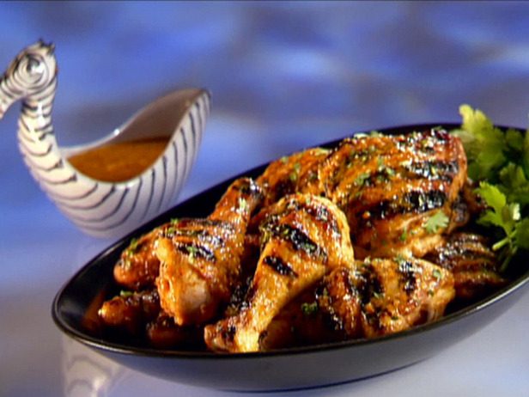
Chipotle-Mango BBQ Chicken
Recipe courtesy Guy Fieri
This barbecue chicken recipe is the perfect sweet and spicy summer dish. Invite all your friends over and fire up the grill! You can also make this recipe with boneless, skinless chicken breasts and olive oil instead of canola oil, for a leaner version.
Cook Time: 25 min
Level: Easy
Yield: 2 to 4 servings
Ingredients
1 1/2 cups mango, peeled, pitted and roughly chopped
3/4 cup fresh cilantro (loose pack, not chopped, stems and all)
2 chipotle peppers in adobo, plus 1 tablespoon adobo sauce
2 tablespoons unseasoned rice wine vinegar
4 cloves garlic, peeled
2 tablespoons fresh lemon juice
1 tablespoon canola oil, plus extra for grill
2 teaspoons kosher salt
1 teaspoon freshly cracked black pepper
2 pounds chicken thighs and drumsticks, bone in, skin on
Directions
Put the mango, cilantro, chipotle, vinegar, garlic, lemon juice, 1 tablespoon of oil and salt and pepper, in a food processor and puree until smooth. Adjust seasonings, to taste.
Add the chicken with half the mango mixture to a resealable plastic bag, and massage to coat the chicken with the sauce. Refrigerate at least 6 hours to marinate.
Put the other half of the mango mixture into a small saucepan and simmer over low heat until thick, stirring often, about 15 minutes. Set some of the simmered chipotle-mango sauce aside to serve on the side and baste the chicken every few minutes with the rest of the sauce.
Preheat a grill or grill pan to medium-high heat and brush with canola oil. Remove the chicken from the marinade and put on the grill.
Grill the chicken turning and basting about every 5 minutes until cooked through, about 20 to 25 minutes. Transfer to a serving platter and serve with the reserved mango sauce.
Adapted from: http://www.foodnetwork.com/recipes/guy-fieri/chipotle-mango-bbq-chicken-recipe/index.html
EXERCISE OF THE WEEK: Walking
If you are getting bored with your regular walking routine, here are a few ways to increase your intensity or try something new.
Looking for some different scenery?
Try walking through an air-conditioned mall, down a nature path, down the cul-de-sacs of your neighborhood, to the local school, around the track, through Bethesda or DC, through an art museum or the botanical gardens.
Looking to burn some extra calories?
Try carrying light weights while you walk, increasing your speed by 1 mph, increasing the frequency of your steps, choosing a route with lots of hills and valleys, or going for an extra ten minutes.
Looking to make walking part of your daily routine?
Walk to the grocery store or find a weekly errand that doesn’t require a car, pick weekend activities that get you moving, walk in ten minute segments throughout the day, instead of doing it all at once, link walking to another daily activity, for example “before I check the mail, I will go on a walk”.
Looking for some Motivation?
Find a walking buddy, talk with fellow walkers online, set a specific goal for how many times a week you want to walk and for how long, think about winning your Healthy Destinations vacation!

